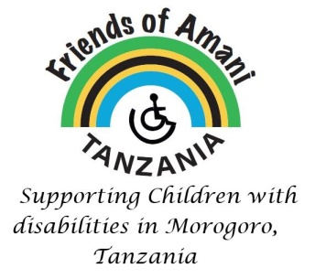
Friends of Amani, Tanzania (FOAT) Charity No: 1114281
FOAT is a UK registered charity dedicated to supporting the Amani Centre to meet its core mission of community based rehabilitation of disabled children and their families. The Charity’s Objects also provide the opportunity for Trustees to advance the education of people with disabilities throughout Tanzania.
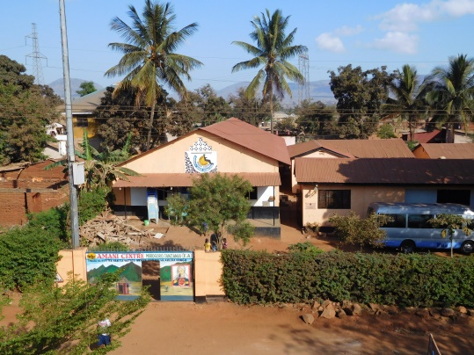
The Amani Centre, Morogoro
The Amani Centre is a small Non-Government Organisation (NGO) with a mission to support young people with mental and physical disabilities and their families. It is located in the Morogoro region of Tanzania, with a main centre in Chamwino, Morogoro and two farm outstations at Mvomero and Mikese.
Amani employs a total of 20 members of staff, mostly volunteers and is home to nearly 70 disabled young people who live across its three sites. It ensures that these young people have safe, productive and educated lives. In 2017 Amani successfully established a primary school on its site at Mvomero, specialising in teaching students with severe hearing impairment.
Amani also offers a range of community-based rehabilitation services (CBR) to the disabled and their families through outreach activities, physiotherapy services and the provision of day care. It also undertakes collaborative projects with other social partners, including the Anglican Church of Morogoro.
Many people with disabilities and their relatives find it quite hard to live positively. Disability is seen as an everlasting burden that stigmatizes the victims and their relatives. Those disabled are either kept inside like animals or left to wander in the country side with all the dangers of sexual abuse and accidents. With the challenges of HIV/AIDS, the care and meaningful accompaniment of the disabled is more urgent than ever.
Amani works tirelessly to raise the awareness of disability and reduce the stigma across Tanzania.
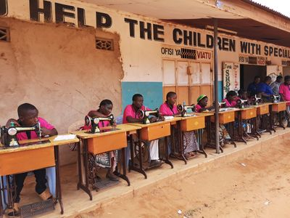
Some current projects
Tailoring
Sponsored by a grant from the Park Family Charitable Trust and supported by FOAT, this project began in January 2019 with a total of 17 students with disabilities from the Amani Community in and around Chamwino. The Tailoring Project gives the young disabled a skill they can use to earn an income for their families and Amani.

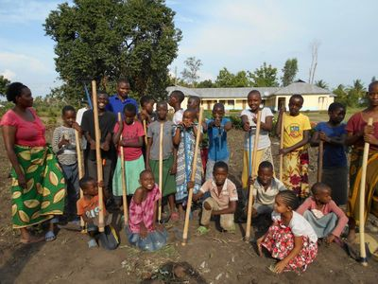
The Agriculture Co-Curricular Project

The Co-Curricular Project at Amani Mvomero Primary School is an exciting and innovative project launched in February 2019, funded by a grant from the Fonthill Charitable Trust. It aims to use agriculture as a learning opportunity by using the maize field and vegetable garden as an outdoor classroom, where the children can learn about growing maize and vegetables, but can also practise elements of the Government Curriculum.

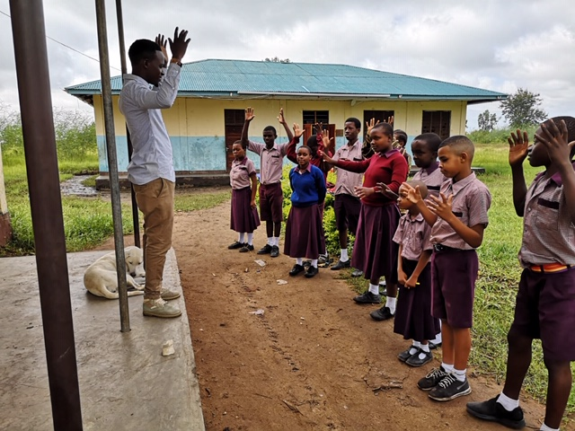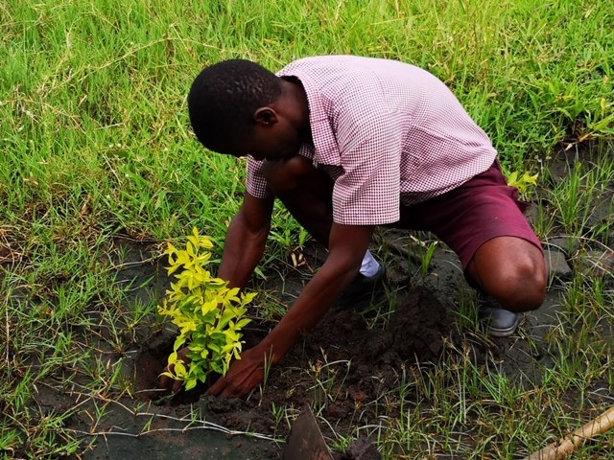
The Fonthill Trust has made a further grant in 2020. This will enable the maize and vegetables to be prepared and grown for a further year and to enable the activities to become more sustainable. Amani also hopes to purchase 40 chickens with the money to help the children learn how to look after chickens and work as a team to develop a small business selling eggs and chickens.

Mpapa Village and Dispensary

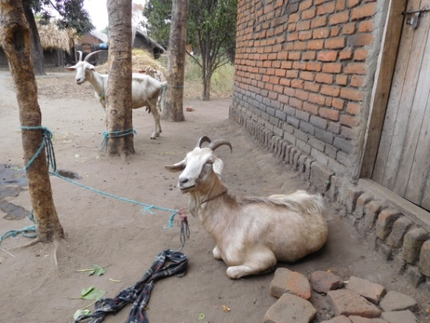
Amani has long supported the families of the disabled in the villages of Mpapa and Msufini through outreach from its Mvomero Centre. In 2007-08 FOAT supported economic social empowerment projects in these communities, teaching families of the disabled the skills of goat husbandry and donating goats for them to rear, use the milk and sell for meat. Subsequently, the villagers have initiated other income generating projects, including a local vegetable garden cooperative.
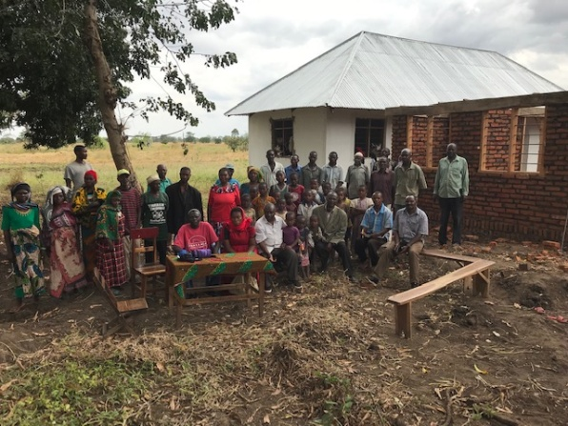
The challenge for these villages is the distance from any form of medical facility. With funds raised by pupils from Dame Alice Owen School in London and a generous private donation, a 10 room local dispensary is nearing completion and expected to open in late 2020.

.

Collaborative Economic Social Empowerment Projects
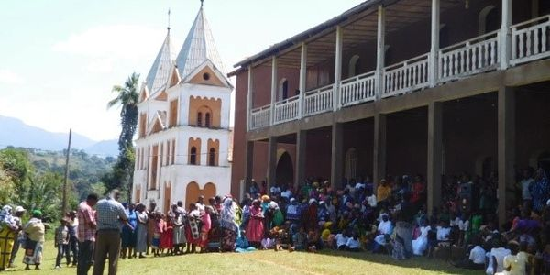
Since 2014, workers from Amani and Berega Hospital have been working together on outreach projects to village communities to raise awareness of disability, carry out assessments of the many disabled children and educate the parents how best to care for the disabled. Many families responded positively to the education on health of the disabled, but the challenge was that of overcoming family poverty.

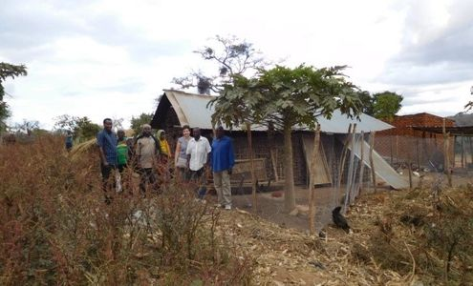
A new phase of this project began in February 2018 focussing on training and supporting small groups of families with children with disabilities to develop small enterprises to generate income for themselves and establish Village Community banks. Chalinze and Tunguli, geographically remote from Amani were chosen from the four villages visited for outreach work.

FOAT is currently seeking funds to develop economic social empowerment projects with families of the disabled in the villages of Chakwale and Matombo.

A New Amani Village at Magubike

The demands for Amani's services are ever increasing. The more Amani does to raise awareness of disability and offer support in the Morogoro Region, the more its services are needed.

Families of the disabled in the village of Magubike, some 60 miles from Amani Centre Morogoro, have been asking Amani to open a new Centre in their locality. They have over 170 children with varying disabilities and find it difficult to get to Morogoro for treatment.
The families lobbied local Government officials to provide land and basic utilities - electricity and mains water. This has now been provided
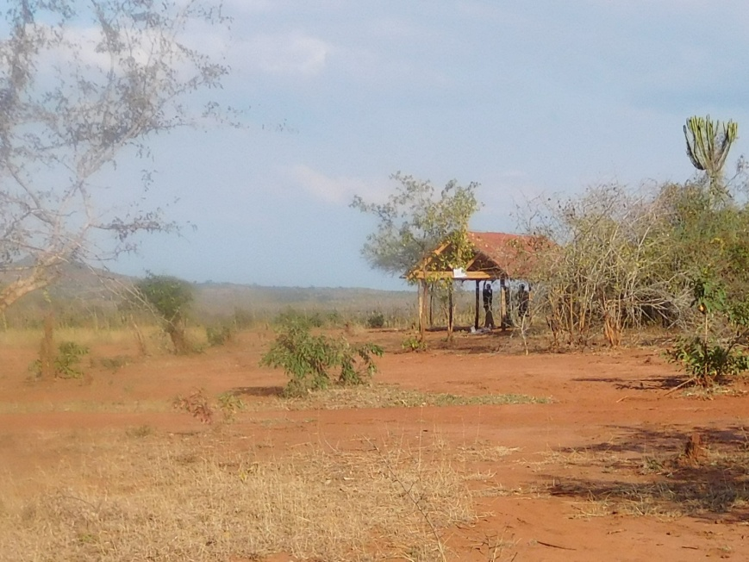
FOAT is working with Amani to raise £13,500 to open the first phase of this new Centre.
Please consider donating to help us reach this target. https://amanitzuk.org/foat-fundraisers
---------------

Registered Address: Jaycroft, Elm Lane, Lower Earley, Reading, RG6 5UG
Web site: https://amanitzuk.org
Email: FOAT@Amanitzuk.onmicrosoft.com
Donations can be made:
- By BACS to: Friends of Amani Tanzania, Account No: 10201087, Sort Code: 16-29-25
- Via Just Giving: https://www.justgiving.com/onecheckout/donation/direct/charity/187738
Gift Aid If you are able to gift aid your donation, please download the form
https://amanitzuk.org/donate-here or contact the charity to request a form

